Lab Plan 9 - Gesture Class

This lab focuses on Flutter GestureDetector usage and interaction handling. Each task is designed to help students understand how touch-based interactions work and how different gestures can control UI behavior.
Task 1: Create a Flutter Application

Task 2: Create an appbar with
-Title: “Gesture Class”
-Also set properties of appbar using theme
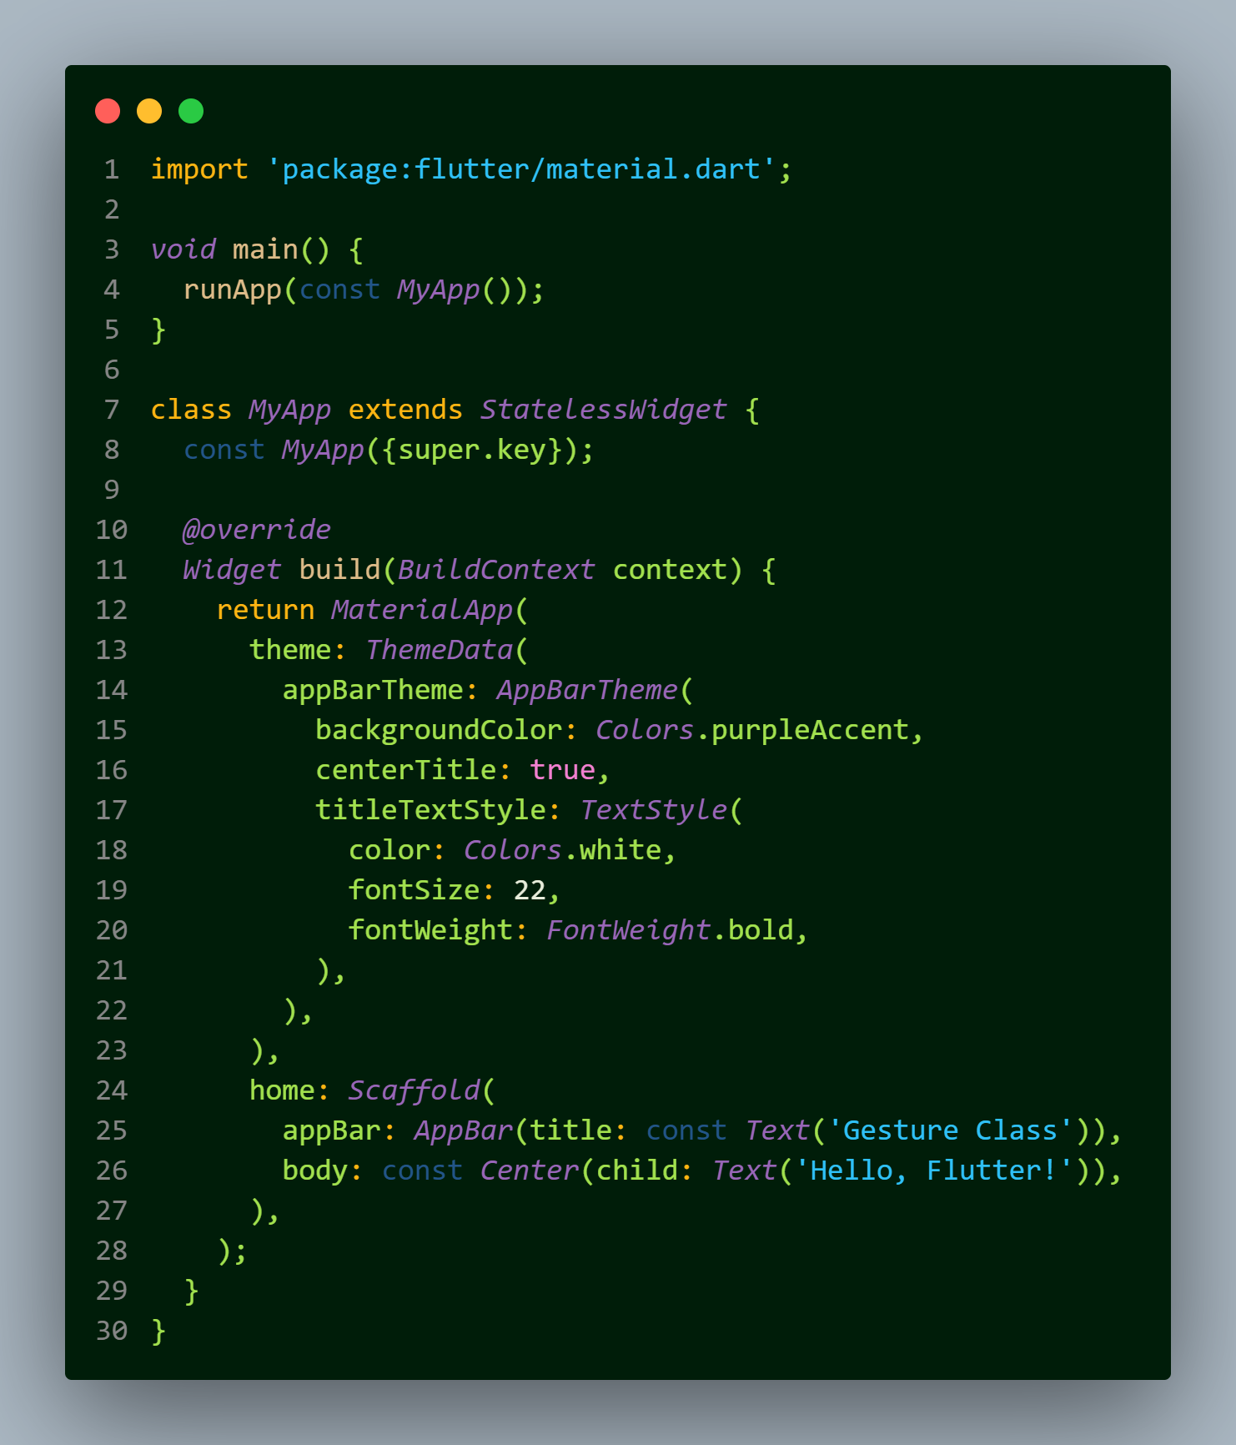

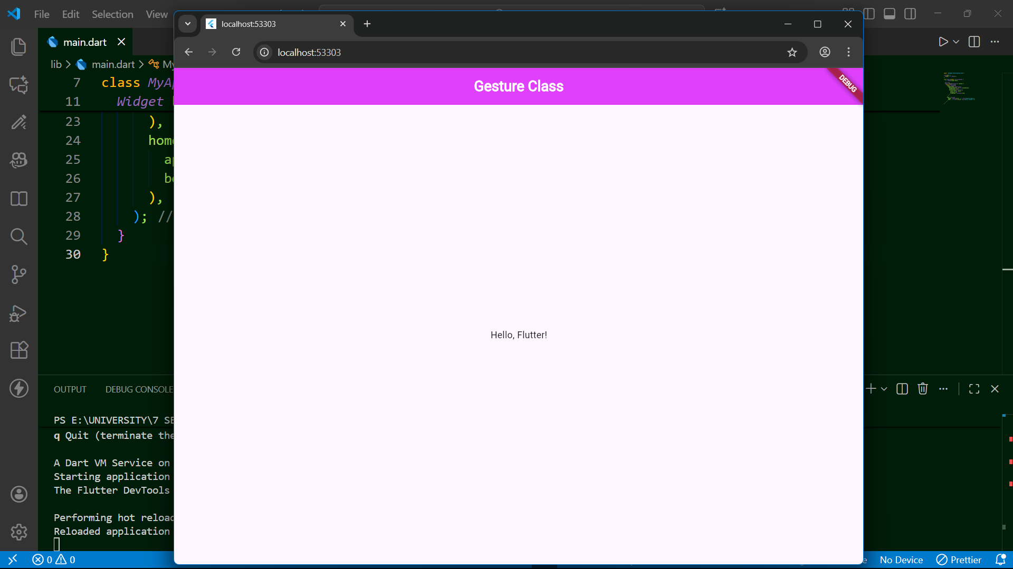
-------------------------------------------------------------------------------------------------------------------------------

Task 3: Background Color Change with Gestures
- Create an application using GestureDetector.
- When the user taps the screen, change the background color.
- When the user double taps the screen, change the background to a different color.
- When the user long presses the screen, change the background to another unique color.

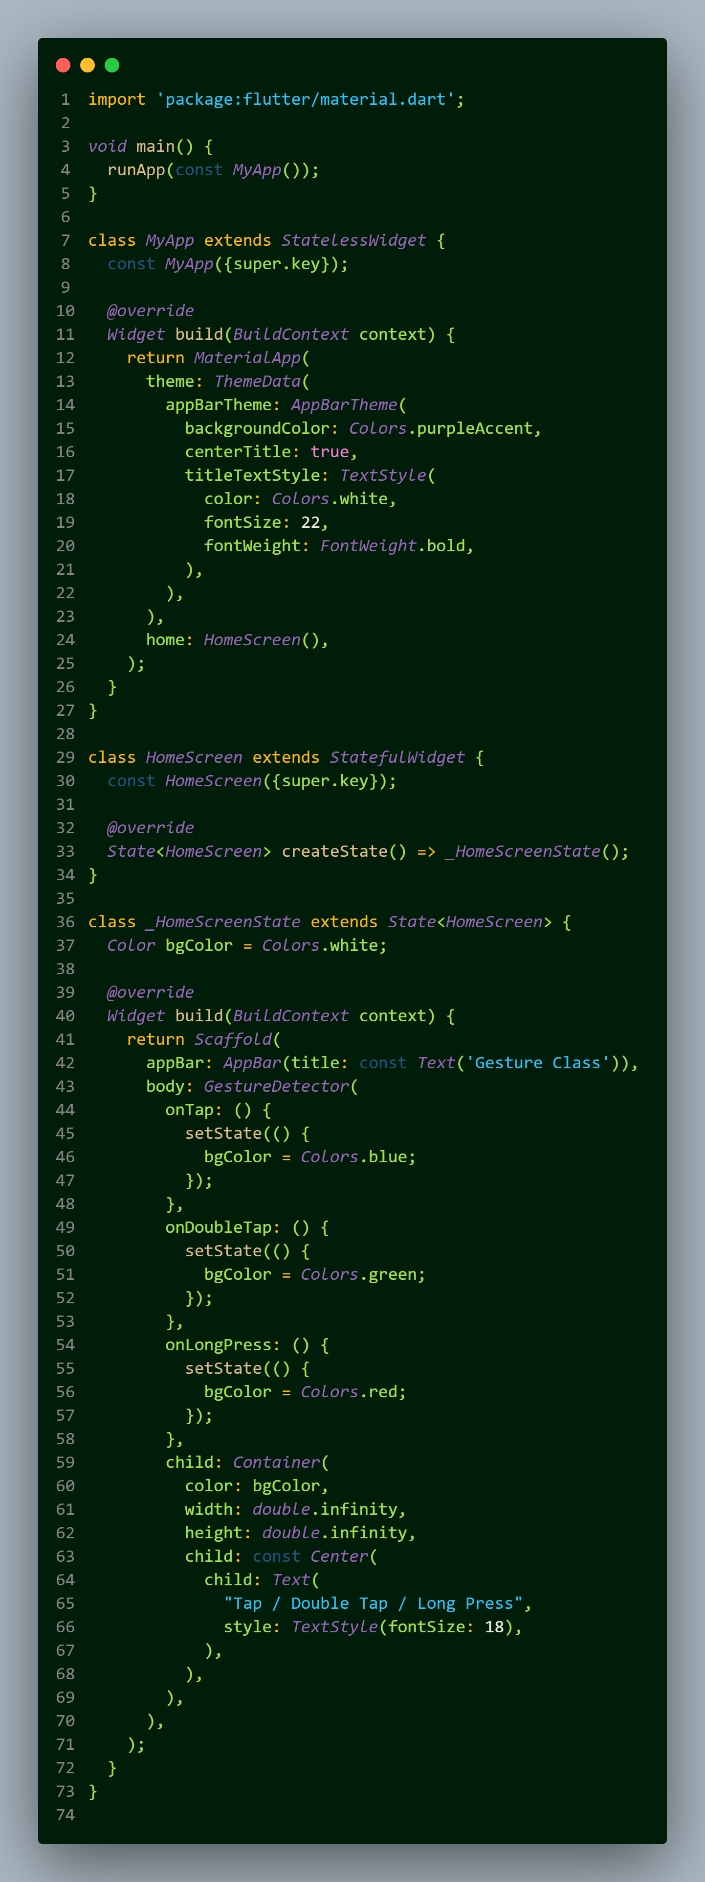
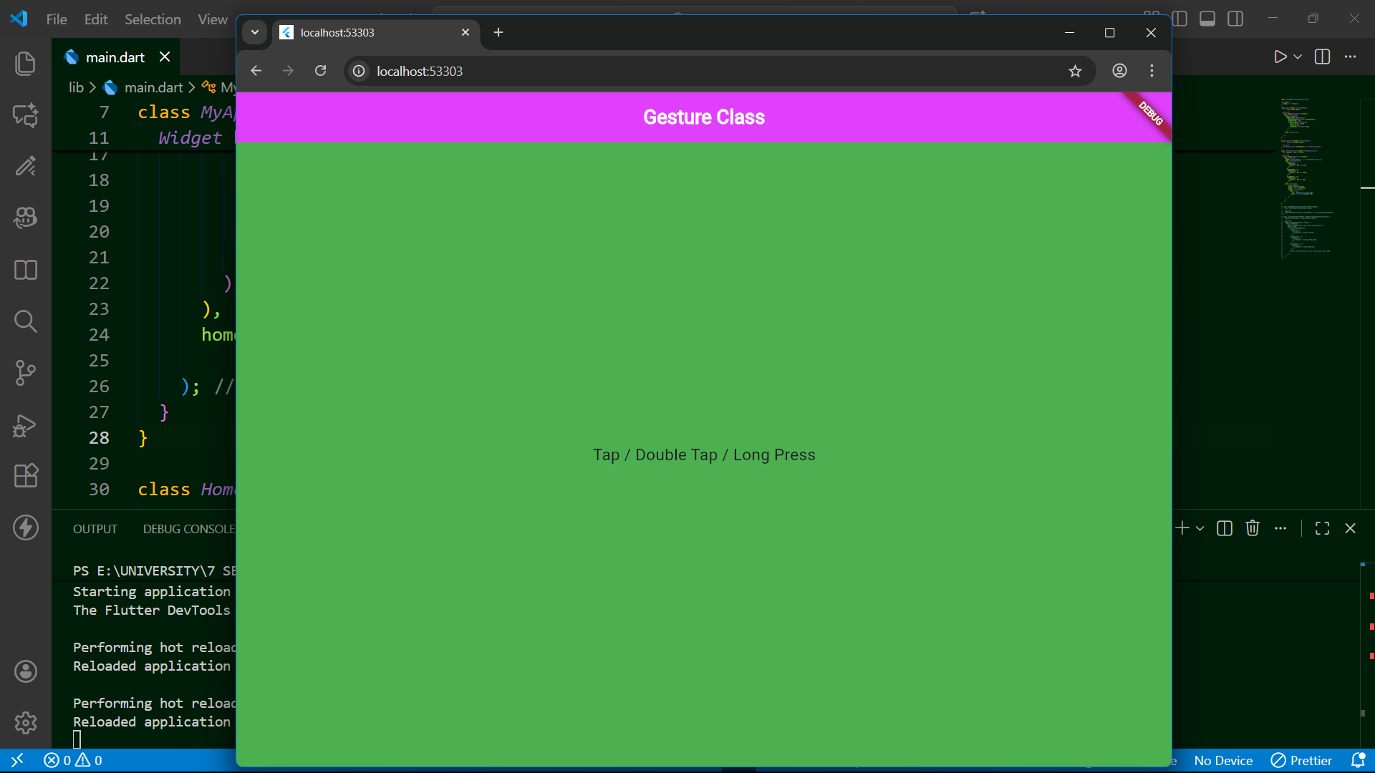
-------------------------------------------------------------------------------------------------------------------------------
Task 4: Icon Change with Gestures
- Create an app with a centered icon.
- OnTap changes the icon to another icon.
- OnDoubleTap changes it again to a different icon.
- OnLongPress replaces it with yet another icon.

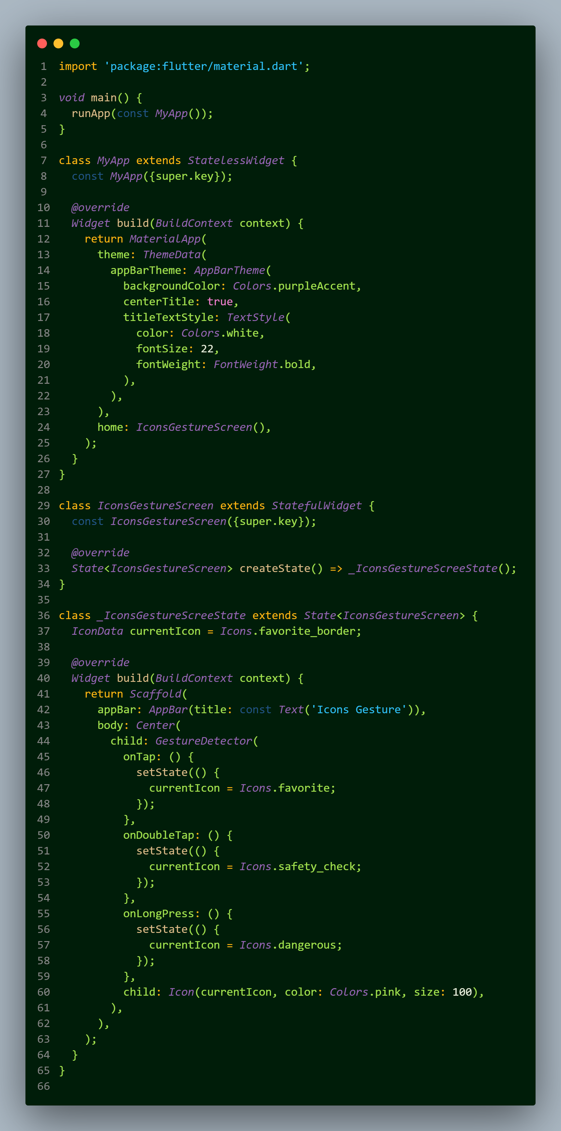
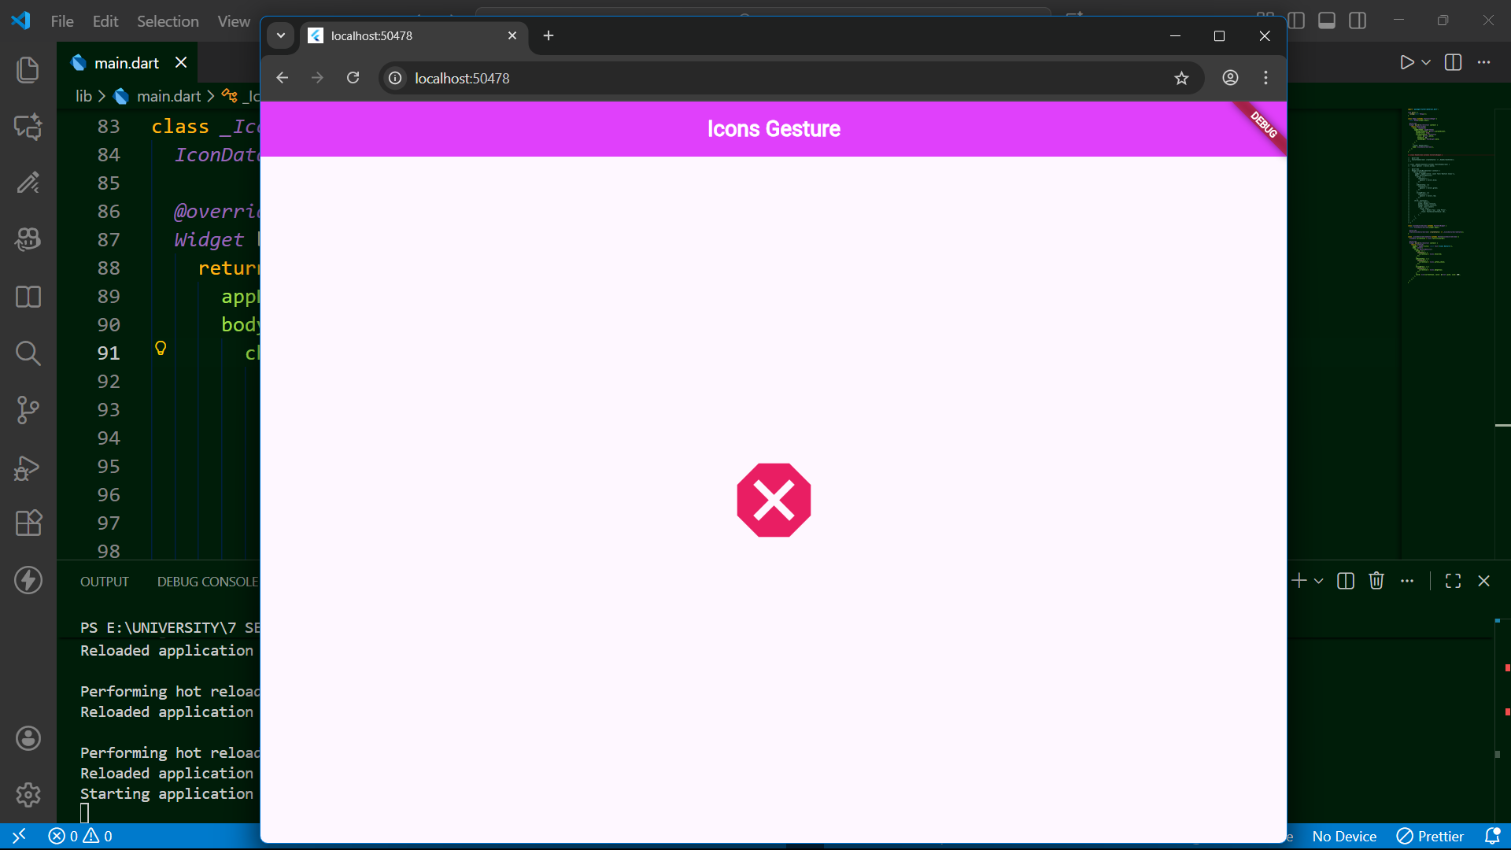
--------------------------------------------------------------------------------------------------------------------------------
Task 5: Gesture-Controlled Counter
- Create an app with a number displayed on screen.
- OnTap increments the value by 1.
- OnDoubleTap increments the value by 5.
- OnLongPress resets the counter to 0.

